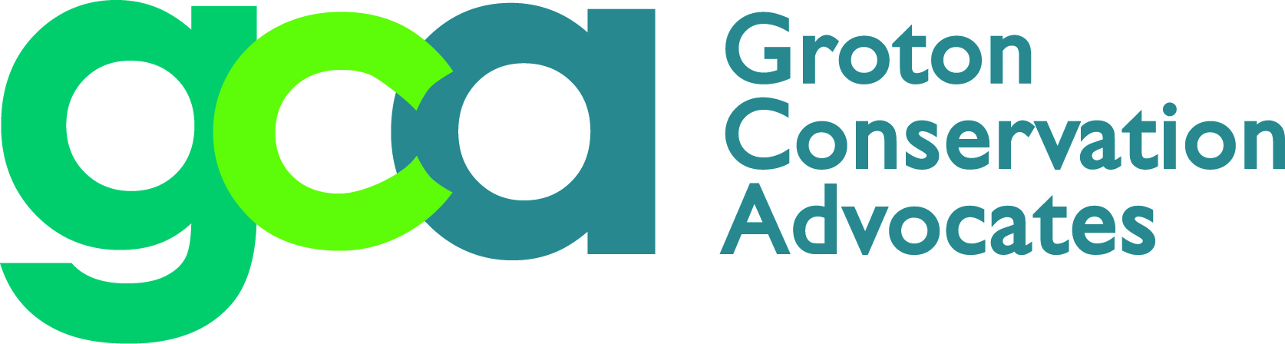

2019 Questions for Town Council Candidates

Please answer the questions below with a yes or no, but feel free to write a longer answer to explain your reasons why. Each question is preceded by an explanatory paragraph, some of which contain links to more information.

Open Space

Land protection benefits our community by providing cleaner, healthier, environmentally beneficial and more appealing places for people to enjoy. Natural areas support local economies by providing recreation, tourism, farmland, and improving nearby property values. Towns also avoid the increased cost of municipal services such as new schools and sewers associated with residential development. (Click here to read more.) Nevertheless, some residents claim that Groton has enough open space at approximately 14% of the total acreage (see page 2-13 of the 2016 Plan of Conservation and Development), although this number is well below Connecticut’s Green Plan goal of 21% by 2023. Other residents claim that the eastern side of town has far more open space than the western side; many more trees to mitigate the problem of urban heat islands; easy access to open space; and fewer instances of undesirable land use.

Q1. Do you think Groton should encourage preserving additional open space and ensure protection of existing open space as an economic and health benefit to the town?

Protected open space also provides recreational opportunities for both our citizens and visitors. In 2012 Bluff Point and Haley Farm together had over 400,000 visitors, showing how important open space is in people’s lives.

Q2. Do you support adding lands to provide active and passive recreation and maintain and enhance the quality of life in Groton? Are you willing to partner with public and private environmental and conservation organizations to create additional recreational areas in Groton?
At present the Town of Groton has only $73,000 in its Land Acquisition Fund for open space and contributions are not part of the Town budget.

Q3. Do you think the town should make an annual investment in this fund through the budget process?

Single-Use Plastics Ban

Since China stopped taking our recycling materials, most towns across America have seen significant cost increases in waste management. Stamford Connecticut went from earning over $70,000 a year from selling their recyclables to paying nearly $250,000 a year to get rid of them. To reduce their waste streams, at least twenty towns in Connecticut have banned single-use plastic bags, several since the statewide law was passed. Many have included plastic straws, stirrers and styrene cups and containers. Groton is considering a ban as well.

Q4. Do you support a ban on single-use plastic bags in Groton starting in early 2020?

Q5. Do you support the town including bans on plastic straws and stirrers?

Studies have shown that styrene (Styrofoam) is one of the most pernicious and long-lasting plastics in the environment. It never breaks down, contaminates food sources, is not recyclable except through an expensive process that is usually unavailable, and is killing or making unknown numbers of turtles, fish, birds, and sea mammals ill — not to mention the litter along our roadways and in our waters.

Q6. Do you support banning styrene cups and carry-out containers in restaurants and other carry-out establishments as a good first step in removing this plastic from the environment?

Updated Tree Ordinance
On June 4, 1995, Groton’s Town Council passed Ordinance #228, Article II, Trees: 15.5-31-38, a prerequisite for Groton to become a “Tree City USA Community.” Its wording offers little protection to healthy trees.
This is an outdated perspective. Trees are good for the environment and human health and well-being. They provide a host of benefits: they absorb carbon dioxide in the air, provide homes to birds (on the decline) and other animals, wick up water that could otherwise cause flooding, hold soil in place to prevent erosion, and keep temperatures lower by providing shade. A more protective ordinance, such as the City of Hartford Tree Ordinance, would ensure that trees, especially climate-resistant species, receive maximum protection in the development review process by prohibiting indiscriminate clearing, requiring replacement, and establishing sustainable replacement ratios (e.g. one tree cut : two trees planted) if removal is unavoidable.
Q7. Would you encourage the Conservation Commission—the tree advisory board to the town—to undertake a rewrite of Groton’s ordinance along these lines?

Water Quality

Groton has been noted for the excellent quality of its drinking water reservoirs. However, trouble may be brewing. At the hearings in connection with the zoning regulations relating to the Groton Reservoir System (“GRS”), Groton Utilities representatives noted that the quality of the water from the GRS has deteriorated. In reviewing the 2018 Annual Water Quality Report, there does not appear to be any reference or data addressing that negative trend. The annual report includes a table of all the contaminants found in the GRS water but not whether they are increasing or decreasing. We believe the public has a right to know what is happening to the quality of its drinking water.

Q8. Would you support a requirement that the Annual Report include comparative data disclosing changes from year-to-year for each of the contaminates?

Climate Resilience & Sustainability

The Town Council this year established the Groton Resilience and Sustainability Task Force. It is charged with making recommendations as to how Groton could best improve the resilience of its built and natural environment and creating a resilience and sustainability literate public for the future.

Q9. Would you publicly support and advocate for the continued work of the Groton Resilience and Sustainability Task Force established by the town council?

For municipal and State planning purposes, the State of Connecticut has codified the University of Connecticut’s projections of a 20-inch rise in sea levels by 2050. Federal Emergency Management Agency (FEMA) establishes the 100-year Base Flood Elevation level, meaning that there is a 1% chance of such occurring in any 100 years. FEMA uses these levels to determine coastal zone and riverine communities’ vulnerability and insurance premiums. Groton’s current regulations require the lowest inhabited floor to have one foot of freeboard above the Base Flood level, but since FEMA’s determinations do not incorporate the predicted 20-inch sea level rise they leave Groton property owners at increased risk. For more information see: https://www.fema.gov/flood-zones

Q10. Would you publicly support amending Groton’s zoning and planning regulations to require two feet of freeboard above FEMA’s Base Flood Elevation for any new or substantially renovated construction in Groton’s flood prone areas?

Renewable Energy

The State of Connecticut has adopted the goal of supplying 40 percent of our electrical power from non-carbon sources by 2030.

Q11. Would you publicly advocate for increasing the Town of Groton’s investment in the installation of solar electric panels (photovoltaics) on additional town-owned properties?

Both of the town’s electric service providers, Groton Utilities and Eversource, offer cost effective energy efficiency services that provide businesses and homeowners with a low-cost energy assessment/audit. These audits pay for themselves as the utilities immediately provide energy saving LED lights, air sealing and other energy saving retrofits. In addition, these audits provide information about significant rebates available to consumers for installing additional insulation and new energy efficient heating and cooling systems that both offset the upfront installation costs and result in reducing their ongoing costs of energy.

Q12. Would you advocate for undertaking a public campaign – potentially including town mailing inserts – to make residents aware of the cost effective energy efficiency services (audits) available to businesses and homeowner customers from Groton Utilities or Eversource?

Climate Challenges

Q13. What do you think are the major climate issues facing your grandchildren in Groton by 2050 and why are these important?

Please return this questionnaire by October 15 to: groconadv2017@gmail.com or mail to GCA, 76 Riverview Ave., Noank, CT 06340

Thank you!

